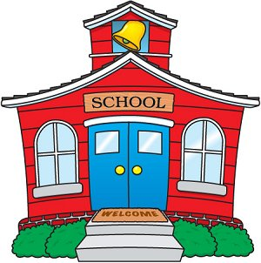

Dear Second Graders,

Welcome to second grade! My name is Mrs. Decker, and I am so excited to be your teacher. I have spent the last 21 years teaching at Jamison, and I know it is a special place to be. My teaching experiences have been in second and third grade, and I have loved every moment.

Second grade will be an exciting adventure for you. You will meet new friends, learn new ideas, and grow so much. In science, you will learn about rocks, habitats, and sound. We will explore communities, economics, and geography in social studies. You will have so much fun learning with technology by using iPads and becoming an expert on topics through research. I hope that you love to read as much as I do. Reading is so exciting when you can enjoy a story or read to learn something new. You will also explore different types of writing and share your writing with others. I can’t wait to have fun learning with you!

I am enjoying the summer with Mr. Decker and our daughters. Madison is going into ninth grade, and she loves to sing and dance. Kaitlyn is excited to start eleventh grade soon, and she enjoys playing softball. One of our favorite things to do is spend time with our little Shichon dog. His name is Buddy, and he loves to cuddle and play. On our free time, we enjoy relaxing by the pool, going on bike rides, watching movies together, and going to softball games. Our favorite summer activity is going to the beach. I can’t wait to learn more about your interests and what you did over the summer!

I look forward to meeting you at Meet and Greet on Thursday, August 25th from 2:30-4:00 pm. You can visit our classroom in Room 105. If you would like to leave your supplies at your desk, you are welcome to bring them with you.

I hope you are enjoying your summer. Is there something special you would like to share with me? If you would like, you can write me a letter before school starts.

I can’t wait to meet you and learn all about you! I am excited to make second grade memories with you!

With a smile,
Mrs. Decker
